User guide

for Applicant Account
of the Unified Information and Analytical System software complex of the State Expert Center of the Ministry of Health of Ukraine

Kyiv 2024
CONTENTS
1 INTRODUCTION 3
1.1. Purpose 3
1.2. Scope 3
1.3. Definitions, abbreviations and acronyms 3
2 GENERAL RECOMMENDATIONS 4
2.1. Work with messages 4
2.2. Work with data entry forms 4
2.3. Work with tables 5
3 AUTHORIZATION 7
3.1. Login/password 7
3.2. Authorization with QES key 8
3.3. Authorization with token 8
4 WORK WITH REGISTRATION FORMS 10
4.1. Register of registration forms 10
4.1.1. Creation of registration forms 10
4.1.2. Search for applications and registration forms 10
4.1.3. Viewing the application registration form 11
4.2. Adding an eCTD dossier 14
4.3. Downloading eCTD dossier files 15
4.3.1. Validation status 16
4.3.2. Validation report on the last submission 17
4.3.3. Previous submissions of the current application 19
4.3.4. Status of transfer to digital archive 19
5 SIGNING OF PDF FILES WITH DIGITAL SIGNATURE 22
6 FINAL PROVISIONS 26

INTRODUCTION

1.1. Purpose
This guide is intended for users of the Applicant Account (hereinafter - Applicant Account), as part of the Unified Information and Analytical System software complex (hereinafter - System) and contains all the necessary information on its application.

1.2. Scope
The document is intended to provide assistance in solving issues that may arise in the process of work with Account.
For successful work users of Account need:
- basic knowledge and skills in MS Windows OS;
- knowledge of office programs at the user level;
- Internet browser skills.

1.3. Definitions, abbreviations and acronyms

Definition | Description
System | Unified Information and Analytical System software complex of the State Expert Center of the Ministry of Health of Ukraine.
Account | Applicant Account of Unified Information Analytical System software complex of the State Expert Center of the Ministry of Health of Ukraine.
Page | Interface of public part is available for viewing and use in System.
Navigation menu | A line element that allows you to open an available page.
Register | Displays information entered on the register cards in table format. Each line of the register corresponds to one card.
Paging | Page-by-page display of data in the register.
Register card | Electronic registration form, which contains fields and tables intended for entering information.
Popup window (popup form) | A window that opens on top of the main register card as a result of certain actions. This window blocks work with the card from which it was called until the work in this window is completed and the window is closed.
Detailed form | A pop-up window that is called from the register card when editing data in tables of this card.
Locked buttons (not available for use) | Buttons that are not available for use. When you click on such a button, no action takes place. In this case, the buttons become dim.
Blocked fields (not available for use) | Fields in which it is not possible to enter data. In this case, the fields become dim.
Check box or logical feature | Interface form element with switch properties.

GENERAL RECOMMENDATIONS

2.1. Work with messages
Interaction with the Account will result in the following events. If the event has a status or message for user, this message will be displayed in the upper right corner of the page.
Results of event and messages can be of two types:
- Error. Shown in red. Contains the name of error and its details, if available.
Figure 1 Example of error with the specific message text

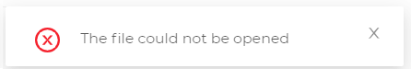
Figure 2 Example of common error

- Successful message. Shown in green. Contains message for user with additional information.

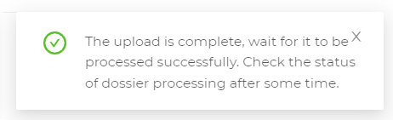
Figure 3 Example of successful message

2.2. Work with data entry forms
Account has a large number of forms for entering data. All forms behave the same way.
Saving/transferring data is performed after clicking the Save button or a button corresponding to the logic of the form.
Form validation results are displayed in the user interface next to each data entry field.
When checking the data, if the field is mandatory, it is highlighted in red and a corresponding error message is placed below it.

Figure 4 Errors when filling in mandatory fields

2.3. Work with tables
Tables consist of the following main elements:
- Table header
  - If the data type in table allows you to sort it, you will be able to click on column in the table header. For such columns, a visual hint and arrows in cell will be available.
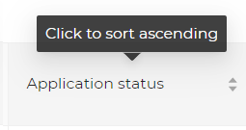
Figure 5 Column in the table by which you can sort

  - If column allows you to filter data, then the filter display will be available in the table header cell.
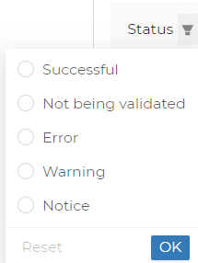
Figure 6 Column in the table by which you can filter

- Lines with data
If there is no data in table, or there is no data corresponding to the specified filters, then the table will be empty and a corresponding message will be displayed.
Figure 7 Display of empty table

- Ability to navigate through pages
If there is a lot of data in the table, a page navigation block will appear (paging). This block allows you to choose which page to go to and how many lines to display on one page.
Figure 8 Navigation through the table pages

AUTHORIZATION
All user actions in Account must be performed after authorization.
Available authorization methods will be offered on the Account login page.

Prerequisites:
Applicant has already had an account in the System.

3.1. Login/password
Authorization is conducted by entering your login and password according to the form below (Fig. 9).
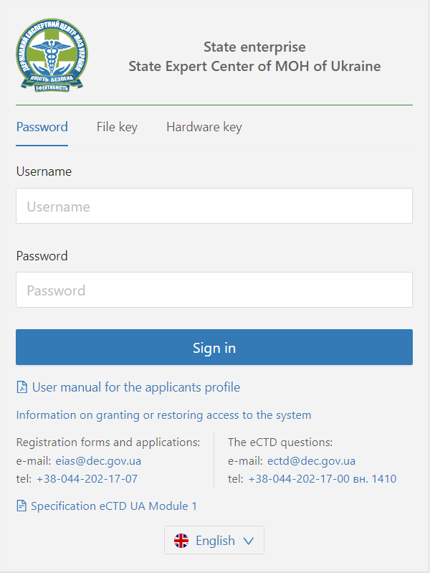
Figure 9 Login/password authorization form
You need to fill in the form and click Login. If account is blocked or user with the specified login and password is not found, a corresponding message will be displayed.

Example:
Figure 10 Authorization error

3.2. Authorization with Qualified electronic signature (QES) key
Prerequisites:
- Applicant configured the Crypto Gates Plus module to work with QES keys and tokens, to sign and encrypt data. You should refer to the Crypto Gates Plus user guide.
To authorize using the QES file key, select File key on the authorization page, select file with the QES key, enter password and click Login.

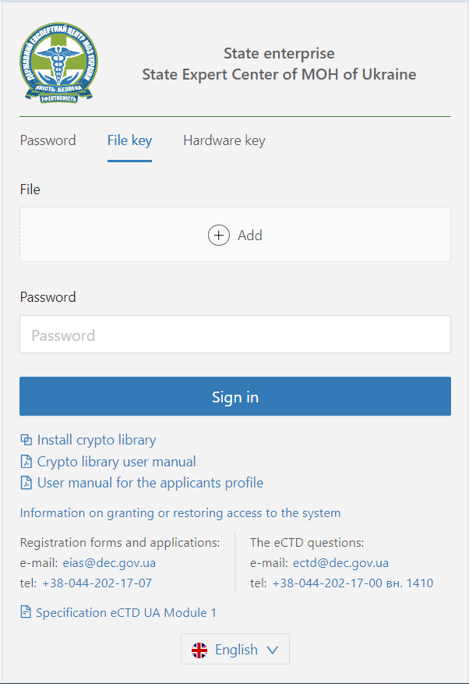
Figure 11 Authorization form using QES file key

3.3. Authorization with token
Prerequisites:
Applicant configured the Crypto Gates Plus module to work with QES keys and tokens, to sign and encrypt data. You should refer to the Crypto Gates Plus user guide.

To authorize using QES key, located on a physical device (token), select Hardware key on the authorization page.
First, you need to select a token with key from the drop-down list, enter the key password and click Login.
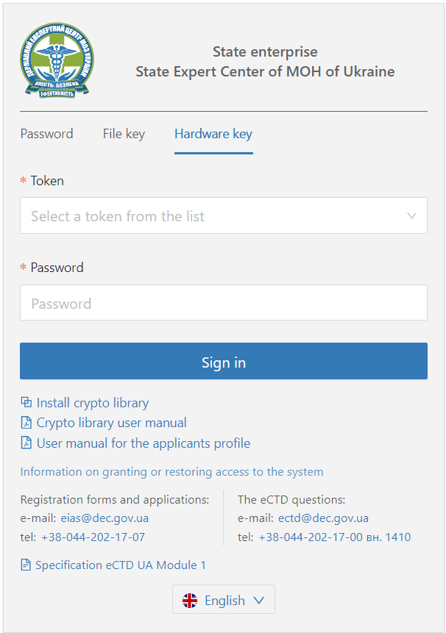
Figure 12 Authorization form using QES key on token

WORK WITH REGISTRATION FORMS

4.1. Register of registration forms
On the Applications tab of Account, the register of applications is displayed - a list of application registration forms available to user in form of spreadsheet.

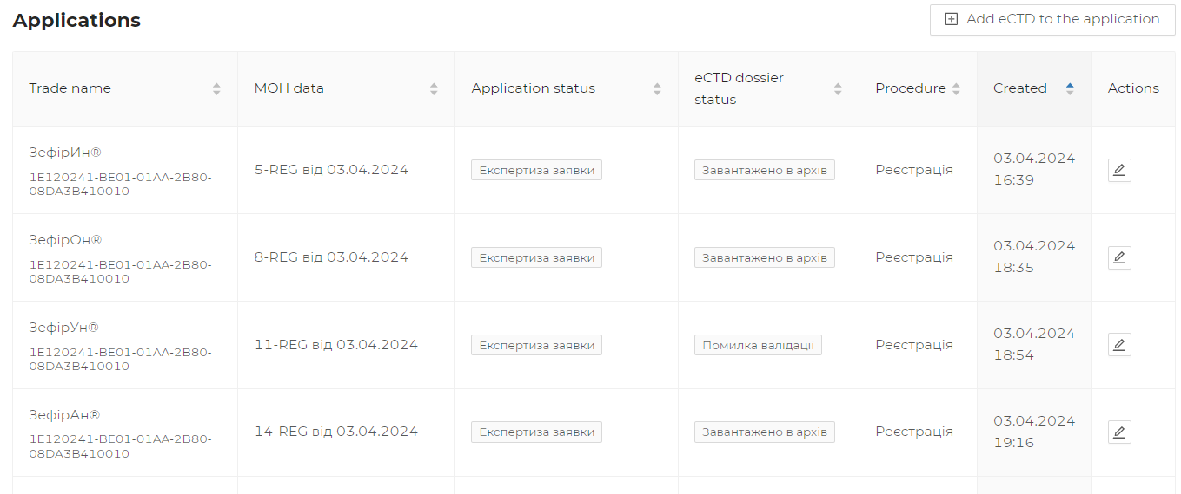
Figure 16 List of application registration forms (in tabulated format)
Available data columns:
Data column | Description
Trade name | Product name is displayed
MOH data | MOH application № and date of MOH application are displayed
Application status | Status of processing application by experts is displayed
Status | Local status of application is displayed
Procedure | Application procedure is displayed
Created | Date and time of application creation are displayed
Actions | Possible actions with application are displayed in column

4.1.1. Creation of registration forms
To create a registration form and download dossier materials in eCTD format, it is MANDATORY to have a universally unique identifier (UUID) with which the file is downloaded at the stage of creating the form.
Attention! The registration form includes this attribute as optional, but system will be able to determine the further formation of the eCTD life cycle only by this attribute.

4.1.2. Search for applications and registration forms
To search for applications, use the Filters block.
To do this, enter the name of the product (or part of the name) or the application № in the Search field and click the Filter button.
It is possible to combine different filters for a more detailed search.

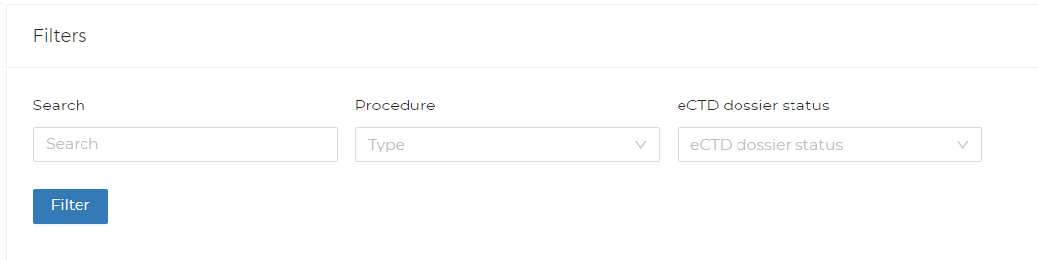
Figure 13 Applications filtering block

The application search is also conducted:
- by type of procedure - select the required procedure in the Procedure field of the Filters block;
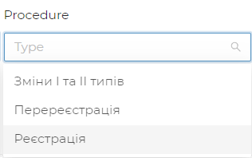
Figure 14 Filtering parameters by procedure type

- by status of application - select the required status in the Status field of the Filters block.
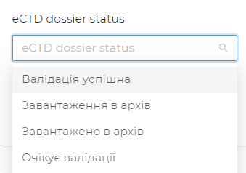

Figure 15 Filtering parameters by application status

After setting the search parameters, click the Filter button. The search results will be displayed below in table with applications.

4.1.3. Viewing the application registration form
To view the details of the application and work with it, first find it in the register of registration forms on the Applications tab. To speed up navigation, use the search, filtering, and sorting functions.
To open application card, click on the edit button in the Actions column in the corresponding line of the register.
Figure 17 Button for viewing/editing application

After opening the application card, information on various data sets, grouped in the appropriate tabs, will be available. The application card has the following set of tabs:
- Application information;
- Validation results;
- Expert evaluations;
- Status history;
- Document history;
- Submission.

Figure 18 Bookmarks of the application card

4.1.3.1. Application information
General information on application is displayed on the Application Information tab.

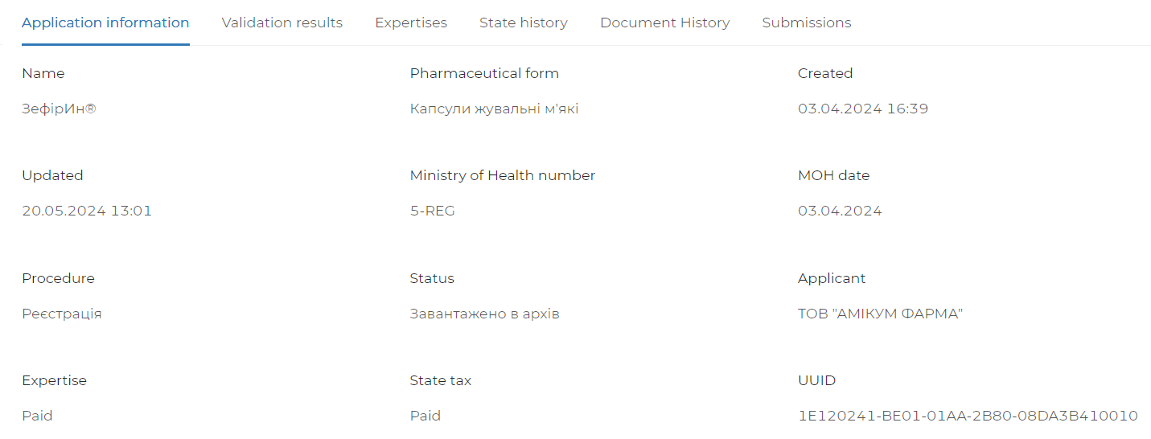
Figure 19 Application basic information
Basic information on application is available:
Data field | Additional description
Name | Product name is displayed in the field
Pharmaceutical form | Product pharmaceutical form is displayed in the field
Created | Date and time of the application creation is displayed in the field
Updated | Date and time of last update (change) of application is displayed in the field
MOH № | MOH application № is displayed in the field
MOH date | Date of application submission to MOH is displayed in the field
Procedure | Application procedure is displayed in the field
Status | Local status of application is displayed in the field
Applicant | Name of applicant is displayed in the field

4.1.3.2. Expert evaluations
Expert evaluations tab displays a list of expert evaluations (in tabulated format) to which the product is referred to. Each table line corresponds to one expert evaluation.
For table with more than 10 lines, paging is available.

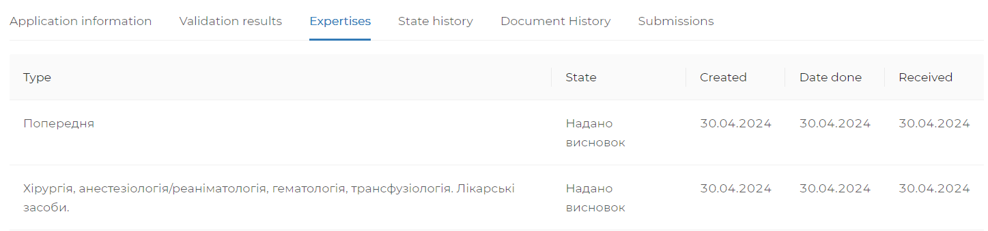
Figure 20 Application expert evaluations (in tabulated format)

4.1.3.3. Status history
The Status history tab displays a history of application status transitions (in tabulated format). Each table line corresponds to one transition.
For table with more than 10 lines, paging is available.
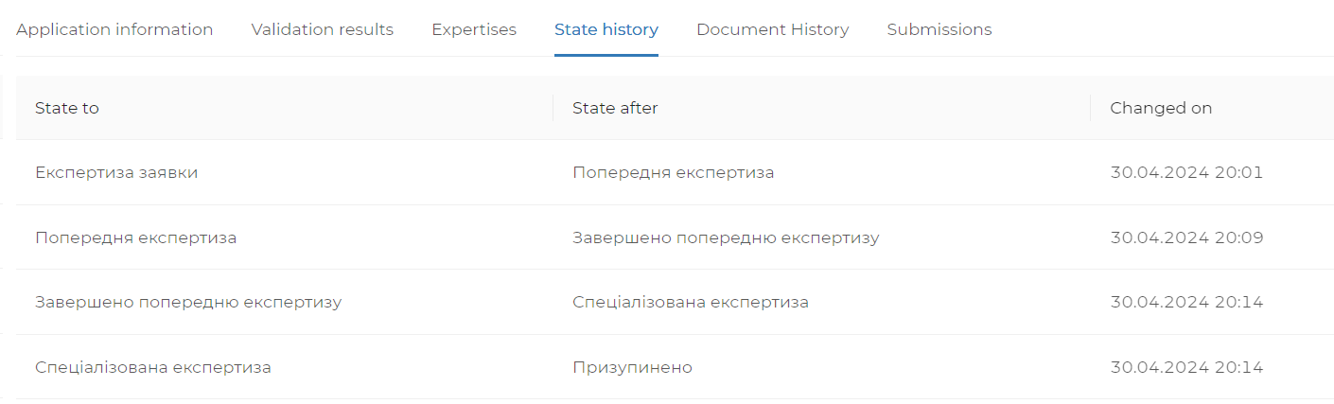
Figure 21 History of application status transition (in tabulated format)

4.1.3.4. Documents history
The Document history tab displays the available documents for application (in tabulated format). Each table line corresponds to one document.
For table with more than 10 lines, paging is available.

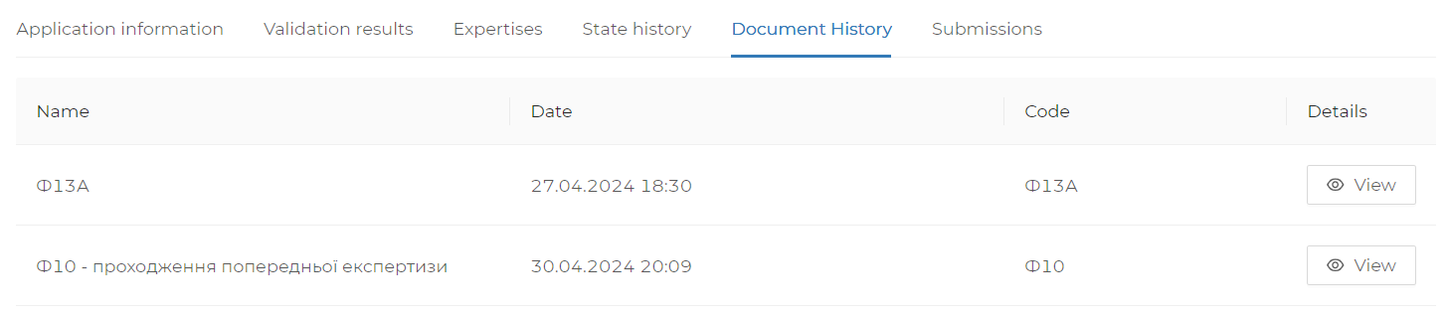
Figure 22 Available documents for application (in tabulated format)

Each document can be viewed or downloaded, depending on the document data type. To do this, click the View button in the Details column for selected document.

Figure 23 Document view button

4.2. Adding an eCTD dossier
To create a new dossier, go to the Applications section and click Add eCTD to the application button or open the form and select a file.
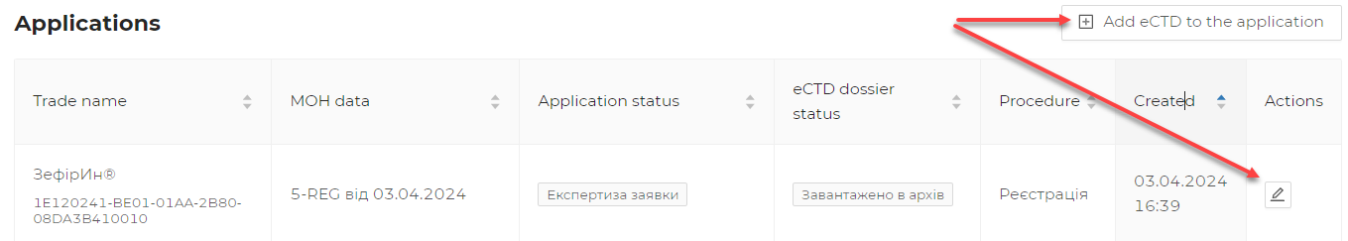
Figure 24 Dossier creation button above the applications table

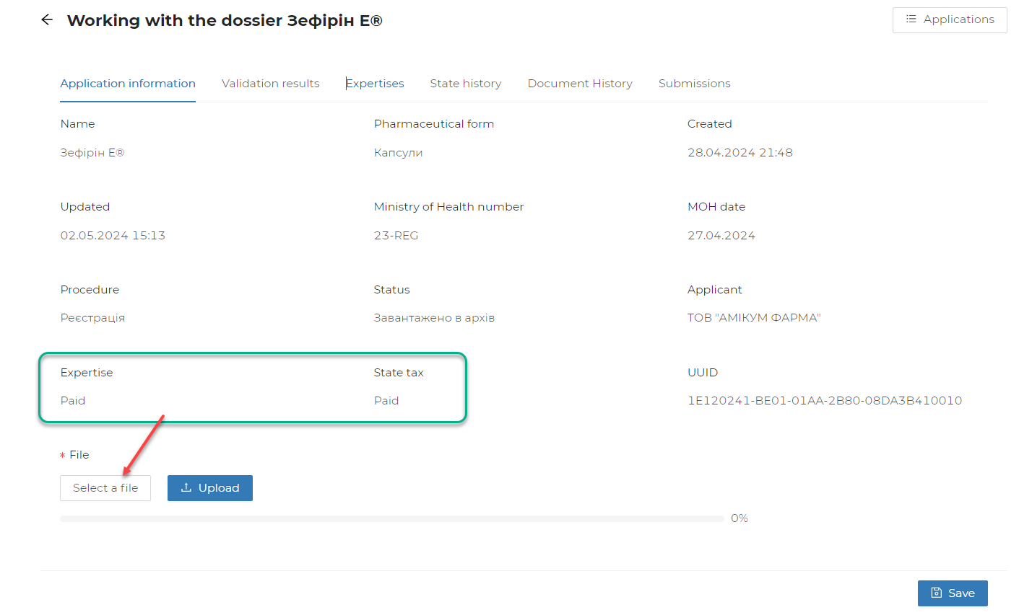
Figure 25 Adding eCTD file to dossier

Attention!!!​ The dossier download buttons are available on the form only after the payments required by procedure are confirmed.

4.3. Downloading eCTD dossier files
The procedure for eCTD dossier file downloading begins with file downloading according to the step-by-step form:

Step 1. Click the Choose file button. Choose a zip archive with eCTD dossier file.
Figure 26 File download form

Step 2. Click the Download button. Wait for the file to download (the download process is displayed as horizontal line). If file is large, it may take some time to download, and the current download status will be displayed below, including the percentage of data downloaded.

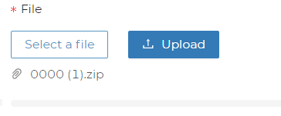
Figure 27 Select file, Start download button

Step 3. After file downloading a green check mark is displayed.
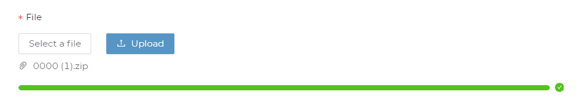
Figure 28 Successful file downloading

Step 4. Click the Save button.
Figure 29 Dossier/application save button

4.3.1. Validation status
After downloading the eCTD archive, Account validates the data. The validation result can be viewed on the application page; you need to refresh the page after a while or go to the application details view.
Application status is displayed in the applications register in the Status column. Also, the application status is displayed in the application card on the Application Information tab - the Status field.
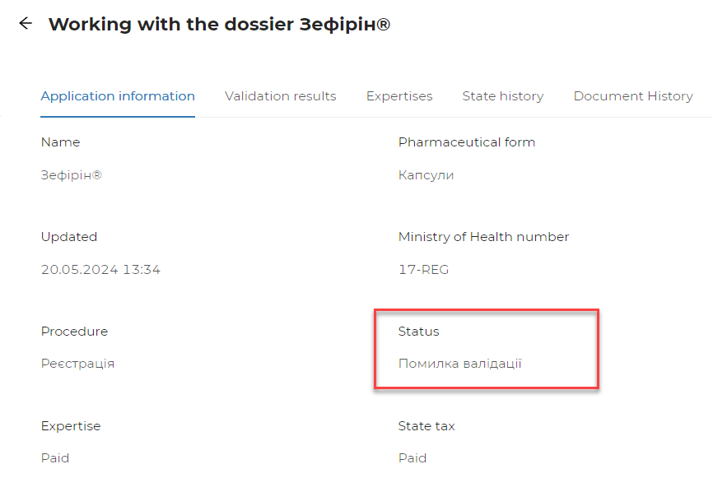
Figure 30 Application processing status

4.3.2. Validation report on the last submission
For each application, where the eCTD archive was downloaded, it is possible to receive a detailed validation report. To do this, go to the application, select the Validation results section.
A table with all relevant validation rules will be available in this section. The number of rules and which ones will be executed during the check depends on procedure type, archive data, and other conditions.
The table with results displays each individual rule executed during the check, which allows you to filter by each rule status and navigate through the pages.

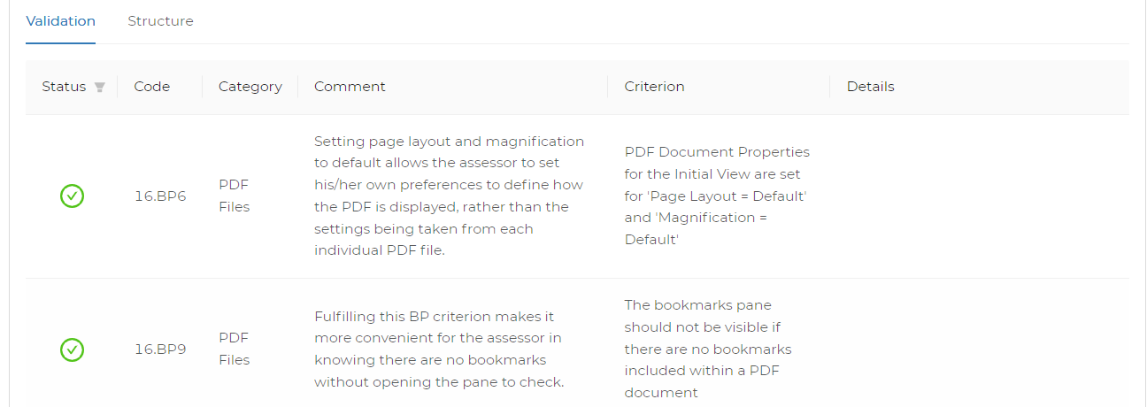
Figure 31 Results of eCTD archive validation for application (in tabulated format)

Data set for each rule checked:
Data column | Description
Status | Final status of the current rule check. Possible statuses are described below.
Code | eCTD validation rule code according to EMA eCTD EU Validation Criteria and regional rules.
Category | eCTD validation rule category according to ICH eCTD, EMA eCTD EU Validation Criteria or regional rules.
Comments | Comment on validation rule.
Criterion | Criterion for evaluating correctness of the rule condition fulfilment.
Details | If rule can be applied to different files, it will indicate which files have violated the checking rule.

All validation results can be filtered by status in the table.
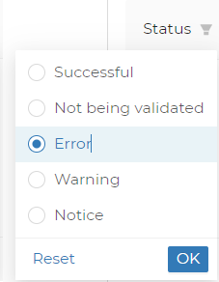
Figure 32 Filter by validation status with eCTD archive validation results (in tabulated format)

Based on the validation results, the following statuses are displayed:
- Successful
- Not checked - the rule is not relevant under the selected check conditions, or cannot be checked in the presence of other errors.
- Error - critical error that prevents the file from being submitted for expert evaluation.
- Warning - violation of recommendation rules (Best Practice).
- Attention - rules that temporarily allow an error, but will be considered an error in the future.
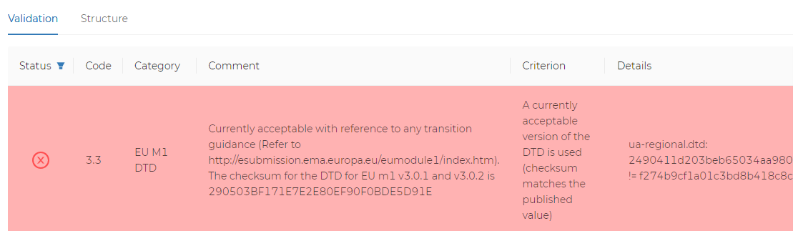
Figure 33 Example of an error when checking rule
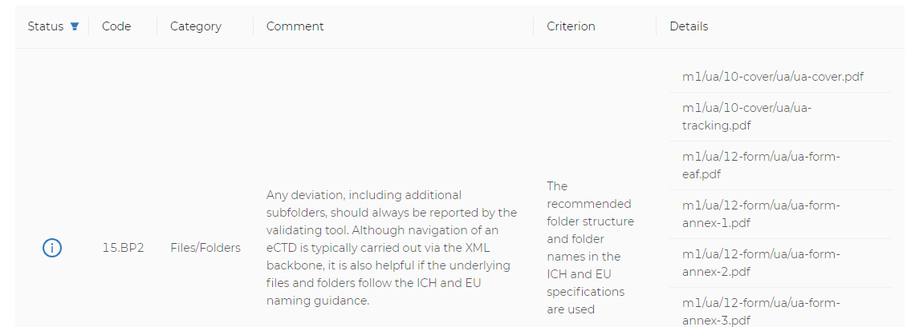
Figure 34 Example of warning when checking rule

4.3.3. Previous submissions of the current application
If several submissions (archives) have been submitted for application, the results of checking and processing of each individual submission will be available in the Submission subsection of the application page.
Each header includes the archive sequence number (sequence), download date and processing status.
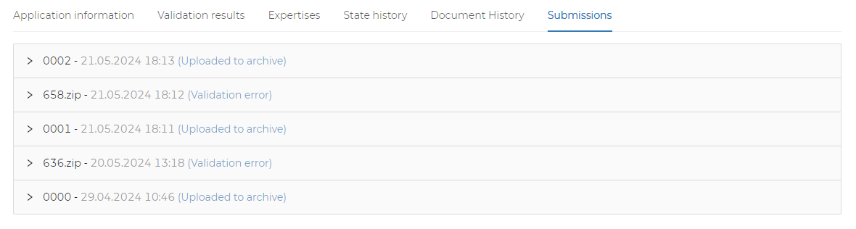
Figure 35 List of previous eCTD archive submissions for application

To view the details of each individual submission, click on the version number line, and the detailed information of this submission will expand.
The report will consist of two main data sets:
- eCTD archive validation results;
- analysis of the submission file structure and downloading to the digital archive.
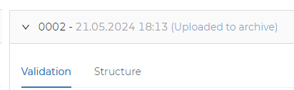
Figure 36 Reports on previous submissions are available

4.3.4. Status of transfer to digital archive

After successful validation of eCTD submission, the file structure is checked and downloaded to the digital archive.
Results are displayed on the Application page, the Submission sub-section, when selecting the appropriate submission and the Structure table. The table with results allows you to filter by file operation type and view by page.

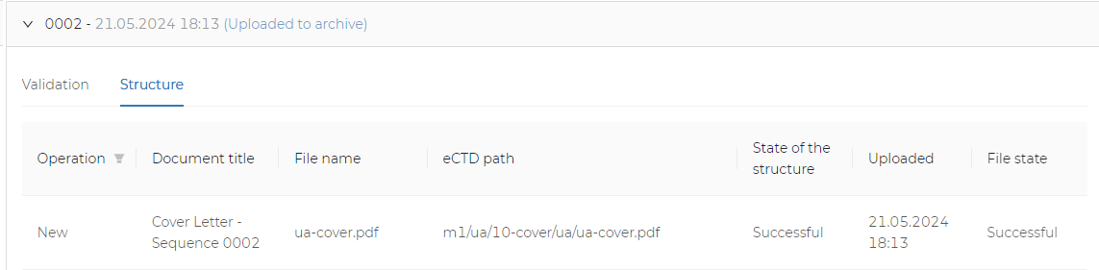
Figure 37 Processing of eCTD archive structure (in tabulated format)

The table with results displays the following information:
Data column | Description
Operation | Type of file operation as specified in eCTD archive
Document name | Document name, as specified in eCTD archive
File name | File name
eCTD pathway | How to place the file inside eCTD archive
Dossier text | Response text when checking dossier files may display text of checking error
Dossier code | Response code when checking dossier files
Downloaded | In case of successful download to digital archive, the date and time of operation will be displayed
Download code | Response code when downloading to digital archive
Download text | Response text when downloading to digital archive may display text of download error

Table with processing results of archive file structure can be filtered by type of operation. To do this, select the type of operation in the Operation column and click OK.
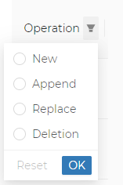
Figure 38 Filter by file operation type

In case of errors during file processing or downloading to archive, messages are displayed in red for each file, as shown below.

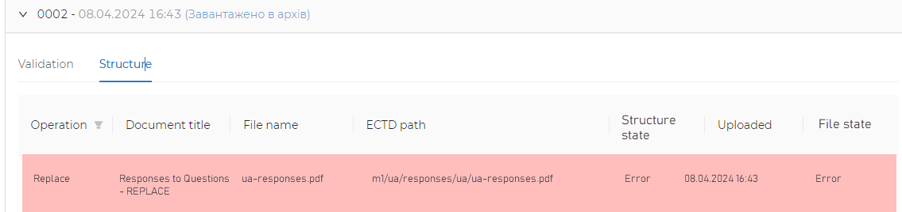
Figure 39 Example of file processing error (in tabulated format)

SIGNING OF PDF FILES WITH DIGITAL SIGNATURE

To sign a file of any format, we recommend to use state service, at the following link: https://czo.gov.ua/sign .

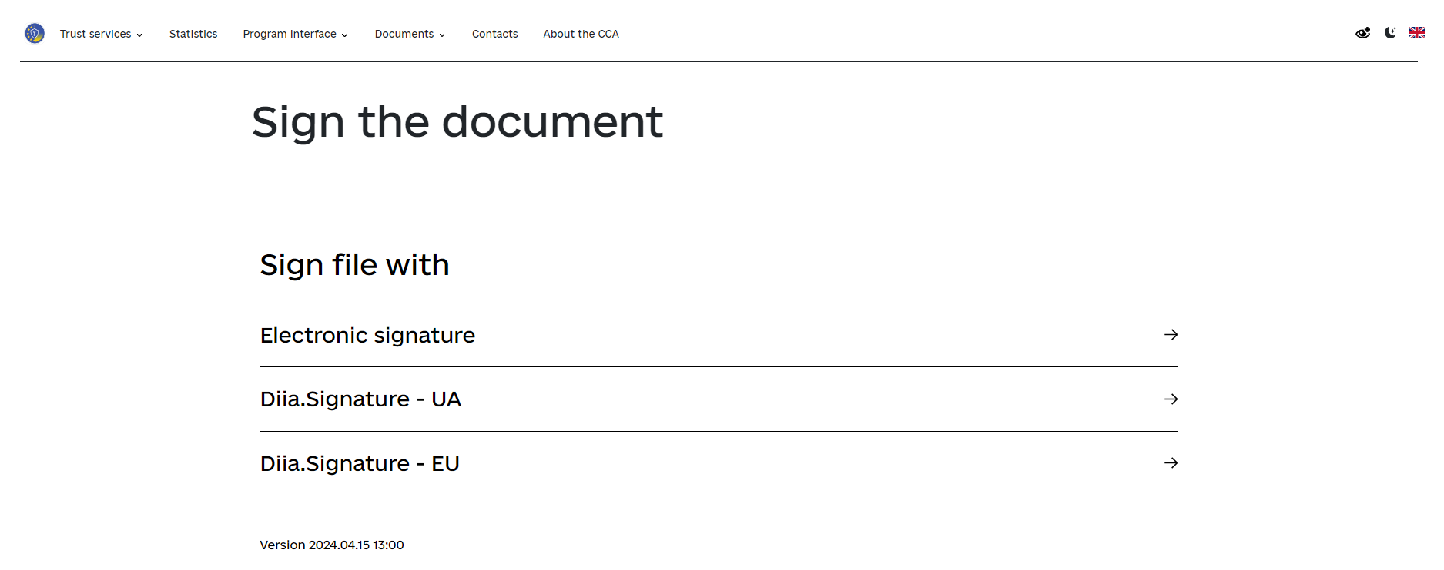
To sign the file with a file key, you need to perform the following steps:
- Choose to sign the file using an electronic signature (the Privatbank file key is used in example)
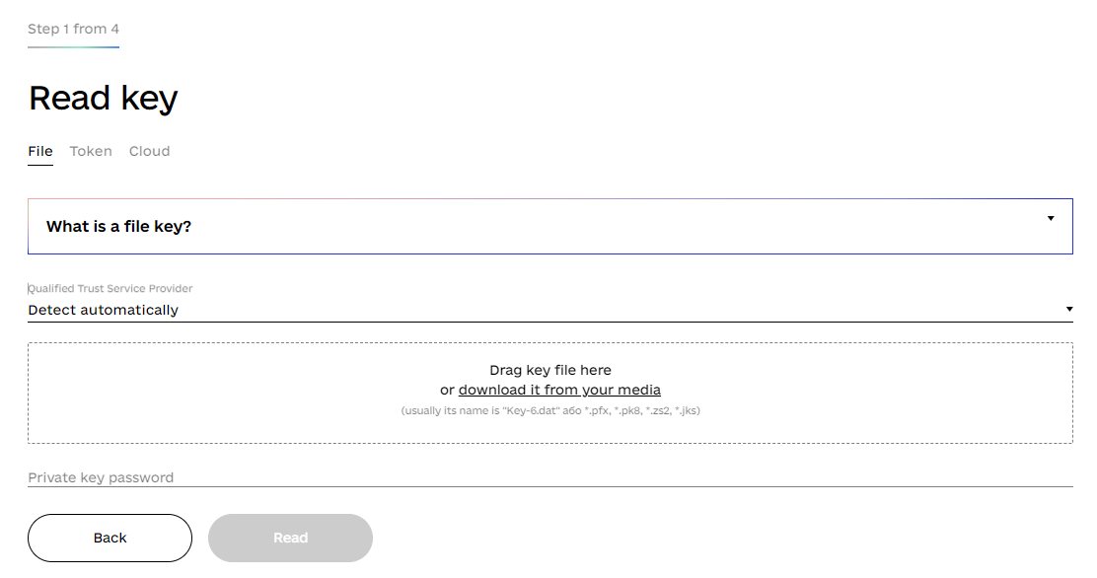
- Download the file key in window using the underlined link.
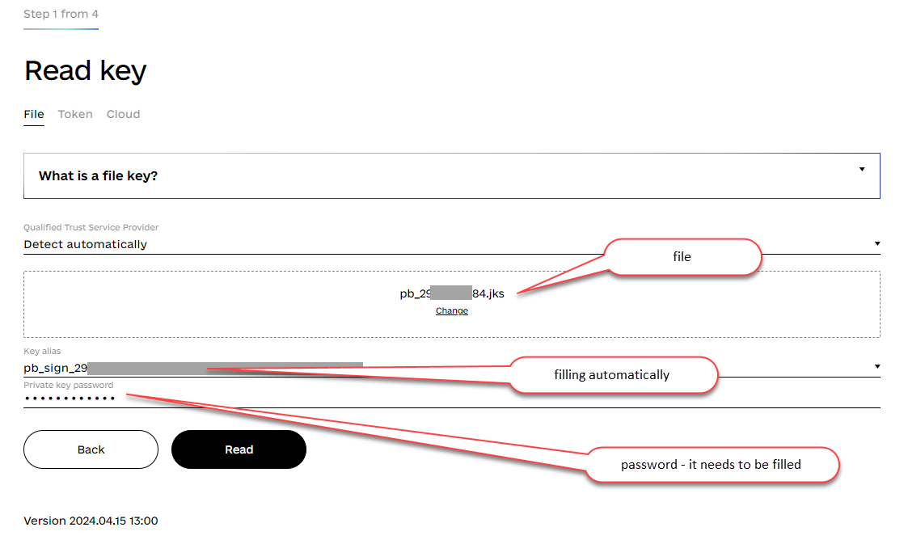
- Click Read, if the file parameters and password are entered correctly, the system will display information about the signature owner.
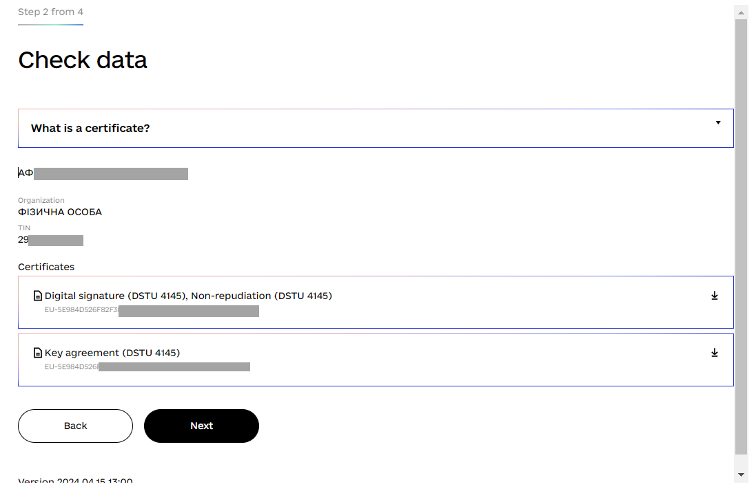
- Click Next and the system will offer to choose the signature format.
Attention: To preserve the readable PDF format of your document, you need to select a different format
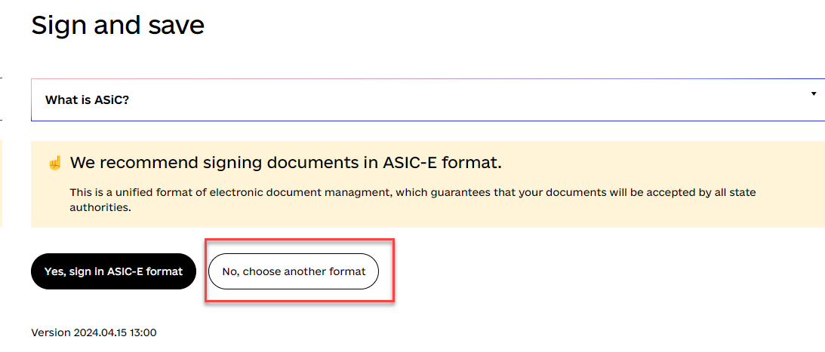
- Click Next and the system will offer to choose the signature format.
Attention: To preserve the readable PDF format of your document, you need to select a different format: PAdes*
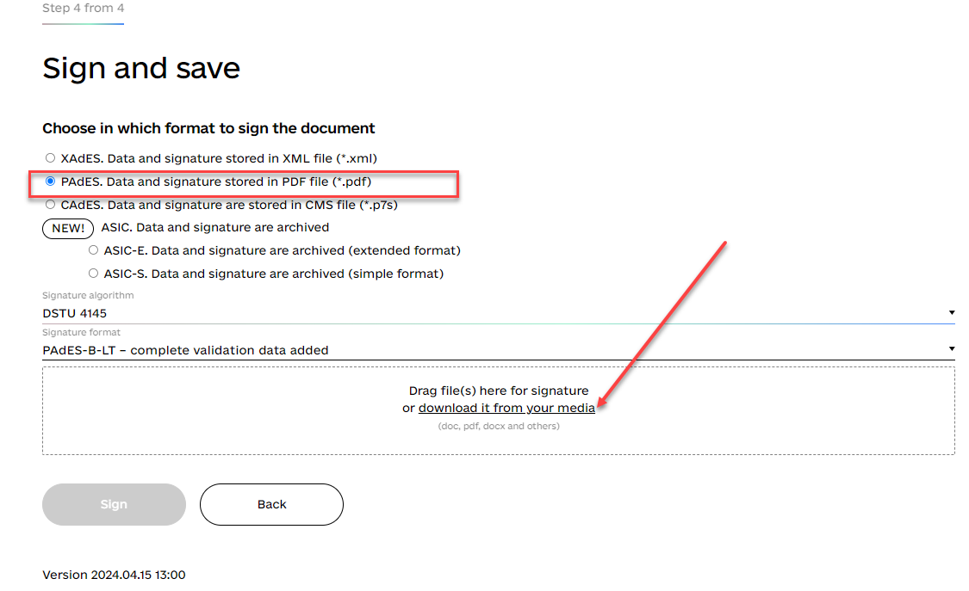
- Drag or download the PDF file you want to sign and select Sign.
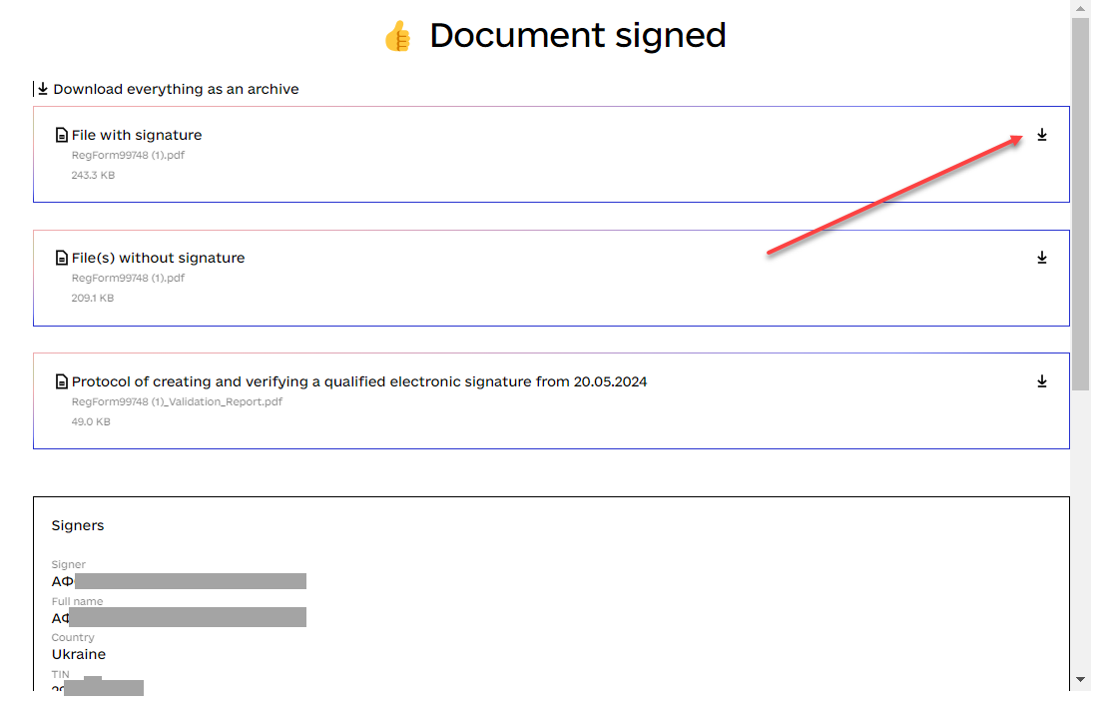
- Download the already signed file to your PC and use it as intended.

* !!!!!! ATTENTION
When signing with a token or cloud signature, the service may NOT allow you to choose the PAdes signing format, in this case you should contact the Accredited key certification authority that issued your signature and clarify which digital signature key supports this format and request such a key from them.

FINAL PROVISIONS
The Applicant Account conducts validation in accordance with the technical requirements of the ICH eCTD Specification v3.2.2. Recommendations for the applicant submission validation according to European technical requirements are also taken into account.
The submission structure shall comply with procedure of submitting materials by the Applicant and the current legislation of Ukraine.
In the case of receiving eCTD validation errors, you should refer to the ICH electronic Common Technical Document (eCTD) Specification v3.2.2 and EMA eCTD EU Validation Criteria and UA Module 1 electronic common technical document (eCTD) specification with recommendations for submitting registration dossier materials in electronic common technical document (eCTD).

