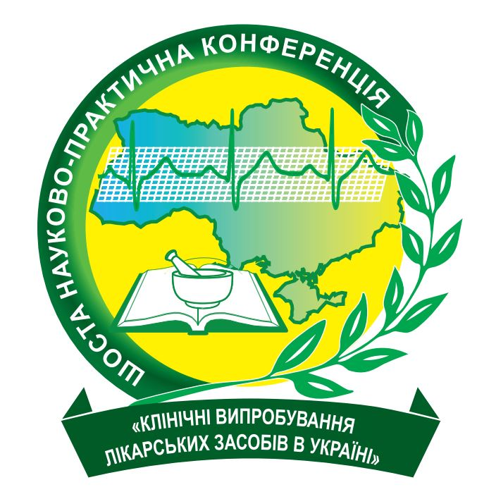

Resolution

of the Sixth scientific and practical conference with international participation “Clinical trials of medicinal products in Ukraine: new challenges and responses to them”

The Sixth scientific and practical conference with international participation “Clinical trials of medicinal products in Ukraine: new challenges and responses to them” (hereinafter – the Conference) was held in Kyiv, Ukraine, on October 8-9, 2020. It was organized by the Ministry of Health of Ukraine, the National Academy of Medical Sciences of Ukraine, the State Expert Center of the Ministry of Health of Ukraine and devoted to topical issues of clinical trials of medicinal products in Ukraine. For the first time, the format of the Conference provided both physical (at the venue) and online attendance to ensure quarantine measures to prevent the spread of COVID-19 according to the current regulatory requirements.
The Conference program included 1 plenary and 14 section sessions. On-line workshop for researchers “Good Clinical Practice (GCP). Regulatory framework for clinical trials” was also conducted on October 9, 2020.
Eighty speakers made 67 oral presentations (including 13 on-line presentations) on various aspects of the organization of clinical trials of medicinal products and protection of safety and rights of their participants.
Leading scientists of research institutes and medical higher education institutions, health managers, doctors of healthcare facilities, members of ethics committees, representatives of domestic and foreign pharmaceutical manufacturers, and employees of contract research organizations from Germany, the Czech Republic, Italy, Switzerland, Ukraine took part in the Conference. The total number of participants was 582 (including 458 on-line participants).
The Conference focused on topical issues of organization, conduct and control of clinical trials of medicinal products while overcoming the consequences of an emergency caused by the COVID-19 pandemic, improving stages of expert evaluation of materials pertinent to clinical trials of medicinal products, current methods and designs of clinical trials, use of e-resources in clinical trials, contentious issues of organization and conduct of clinical trials in the development of different types of medicinal products, use of results of clinical trials of medicinal products for HTA, collection and analysis of adverse reactions during clinical trials of medicinal product.
A particular attention was addressed to issues of the conduct of bioequivalence clinical trials by domestic manufacturers under the pandemic in compliance with the regulatory requirements.
The training workshop for researchers “Good Clinical Practice (GCP). Regulatory framework for clinical trials” was attended by more than 200 on-line participants arouse the interest of the audience. Interesting and urgent topics, and high-level speakers attracted attention even of the most experienced field experts.
Issues of improving the legislative and regulatory framework for clinical trials were actively discussed at the Conference.
The participants of the Conference point out that the Ministry of Health of Ukraine and the State Expert Center of MoH have worked hard to increase the number of clinical trials in Ukraine and prevent the clinical trial sector from shutting down during the COVID-19 pandemic.
A set of regulatory documents were put into effect to ensure the organization and conduct of clinical trials of medicinal products under the COVID-19 pandemic:
- the Law of Ukraine "On Amendments to Some Legislative Acts of Ukraine on Provision of Treatment of Coronavirus Disease (COVID-19)" of 20.03.2020 № 539-IX;
- the Decree of the Cabinet of Ministers of Ukraine of July 22, 2020 № 641 “On introduction of quarantine and stepping up anti-epidemic measures in the area with a significant spread of acute respiratory disease COVID-19 caused by coronavirus SARS-CoV-2” as amended;
- Changes to the Law of Ukraine “Fundamentals of the Healthcare Legislation of Ukraine” of November 19, 1992 № 2802-XII.
However, along with significant advances in the organization and conduct of clinical trials of medicinal products in Ukraine, there are problems that need solving. The following solutions promise further growth of the clinical trial sector:
- Decriminalization of Article 321-2 of the Criminal Code of Ukraine, which currently constrains development of the sector.
- Creation of an electronic document management system, including e-submission of all materials pertinent to clinical trials to the State Expert Center of MoH and e-application submitted to the Ministry of Health of Ukraine after the appropriate changes in the legislation.
- Providing the participants of clinical trials with effective insurance coverage and reaching the appropriate professional level by the insurance companies through amendments to the legislation in terms of improving the insurance system for patients participating in clinical trials, including the Laws of Ukraine "On Medicines" and "On insurance"). This especially relates to the clinical trials under the COVID-19 pandemic.
- Ensuring further development and improvement of the professional and advanced training system for medical staff, which conducts clinical trials in research centers.
- Introducing changes into the Law of Ukraine "On Medicines" in order to establish the public Register of clinical trials.

The Sixth Scientific and Practical Conference emphasizes on a need for such forums in future to discuss issues related to the methodology, organization and conduct of clinical trials in Ukraine and offers:
- To submit a proposal on inclusion of the Seventh Scientific and Practical Conference "Clinical trials of medicinal products in Ukraine" in the Register of meetings, congresses, symposia and scientific and practical conferences of the Ministry of Health of Ukraine scheduled for 2023.
- To recommend the State Expert Center of MoH to facilitate the organization and conduct of training workshops and schools for doctors and researchers, members of ethics committees and other specialists concerning the requirements for clinical trials in Ukraine.
- To promote the publication of guidelines, methodical recommendations, regulatory documents on new approaches to the organization and conduct of clinical trials in order to improve the development of effective and safe medicinal products, including for pediatric population.
- To update methodological recommendations on arranging contractual relations between all physical and legal entities in the clinical trial (sponsors of clinical trials, health-care settings, medical higher educational institutions, research institutes, laboratories, etc.).
- To ensure the periodic update of recommendations of the State Expert Center of MoH for conducting clinical trials until the end of the COVID-19 pandemic.
- To recommend the Ministry of Health of Ukraine to use HTA in decision making on selection of medicinal products engaging all stakeholders to ensure patient’s timely access to cost-effective technologies, which have been proved by high-quality results of clinical trials.
- To contribute to the update of regulations on conducting the early phases of clinical trials, including in healthy volunteers.
- To support the European Business Association’s proposal and recommend the Ministry of Health of Ukraine to address a request to the Ministry of Finance of Ukraine concerning introduction of changes to the taxation of sponsors/applicants and services related to clinical trials, determination of place of service rendering as a place of registration of trial sponsor in case of international multicenter clinical trials, which is of great importance for the effective functioning of the entire clinical trial industry in Ukraine in the future.
- To recommend sponsors of clinical trials and CRO to update the standard technical documentation to clearly specify the allocation of responsibilities between the parties, the subject of contracts, the mechanism of transfer of intellectual property rights, the place of service rendering outside the customs territory of Ukraine, and confirm the export of services rendered by the researchers by the appropriate statement of due form;
- To recommend the State Expert Center of MoH to develop an information resource for sharing experience between the researchers on the technical documentation specified in paragraph 9.
- To support at the state level the position of the World Health Organization and the European Medicines Agency on sharing the results of the Solidarity Clinical Trials for prevention and treatment of COVID-19.
- To support the amendments to the Rules of examination of patent applications related to medicinal products based on the WHO recommendations.
- To recommend the Ministry of Health of Ukraine and the State Expert Center of MoH to ensure the implementation of Regulation (EU) № 536/2014 of the European Parliament and of the Council of 16 April 2014 on clinical trials on medicinal products for human use, and repealing Directive 2001/20/EC, including via introduction of changes to the MoH Ukraine Order of 23.09.2009 № 690.
- To actively involve the media in forums of such level to inform the public about the current approaches to the organization and conduct of clinical trials in Ukraine.
- To publish the resolution of the conference in the magazines “Medicine and Pharmacy News”, “Health of Ukraine", in the newspaper "PHARMACY Weekly", on the web-site of the State Expert Center of MoH, as well as other specialized medical editions.

The Conference participants express the support to the staff of the largest clinical trial center in Ukraine under the leadership of Prof. Igor Bondarenko, who is now under the pressure from the Dnipro’s local controlling authorities. We appeal to the Verkhovna Rada of Ukraine to take this issue under the parliamentary control.

Prepared by the Conference Resolution Committee

Unanimously approved by the Conference participants on October 9, 2020

